Experiment No: 11
Date :17.09.08

ASTABLE MULTIVIBRATOR

AIM

To design and setup multivibrator with
- Symmetric time period.
- Asymmetric time period.
- Vertical edges.

COMPONENTS REQUIRED

SL No: | Components / Equipments | Specification | Quantity
1 | Transistor | BC547 | 2
2 | Diode | 1N4007 | 2
3 | Resistor | 3.3k Ω  82 k Ω  6.8 k Ω | 2  2  4
4 | Capacitor | 0.01µF  0.022 µF | 2  1
5 | Breadboard |  | 1
6 | DC Power supply | 6 V | 1
7 | CRO | Dual Trace 20 Mhz | 1
8 | Digital Multimeter |  | 1
9 | Signal Generator | 20 mV, 1 MHz | 1

THEORY

The circuit of a typical transistor astable multivibrator or free running oscillator using two identical transistors T₁ and T₂. The circuit essentially consists of two symmetrical common emitter amplifier stages, each providing a feedback to the other. The collector loads of these two stages are equal i.e. R_{C1}=R_{C2}, and base resistors are also equal, i.e. R₁=R₂. The output of the transistor T₁ is coupled to the input of transistor T₂ through C₁ while the output of T₂ is fed to the input of T₁ through C₂. The output is taken from either of the collector terminal of T₁ or T₂.

Assume that when the circuit is switch ON, T₁ conducts slightly more then T₂ (due to the difference in β). So the current through T₁ is more then through T₂. This will make a drop in the voltage V_{C1}. This drop is coupled by the capacitor C₁ to the base of T₂ thereby reducing its base emitter voltage. So the transistor T₂ will conduct less. This will reduce the collector current I_{C2} and increase collector voltage V_{C2}. This rise in voltage is coupled by the capacitor C₂ to the base of T₁ thereby increasing its base emitter voltage. Therefore T₁ conducts more and more and T₂ conducts less and less, each action reinforcing the other. Finally T₁ gets saturated and becomes fully ON and T₂ becomes OFF.

Now the capacitor C₁ discharges through R₁ and V_{B2} rises exponentially towards the cut-in voltage V_{rs} (≈0.7V) of T₂. When V_{B2} becomes V_{r2}, T₂ conducts. Therefore V_{C2} drops and this drop is coupled through C₂ to the base of T₁. This will cause V_{B1} to drop. Hence T₁ becomes OFF and V_{c1} rises towards V_{cc} with a time constant τ₁. Now T₁ becomes OFF and T₂ becomes ON.

Again the capacitor C₂ discharges causing V_{B1} to rise exponentially and when V_{B1} reaches the cut-in voltage V_{r1} of T₁, T₁ becomes ON. Therefore, V_{C1} drops causing V_{B2} to becomes negative and cutting OFF transistor T₂. So V_{C2} rises towards V_{CC} with a time constant τ₂. Now T₁ becomes ON and T₂ becomes OFF again. The process repeats again causing the transistors to becomes ON and OFF with a fixed time period. If R₁C₁=R₂C₂, then the ON time will be equal to the OFF time.

Total time period τ = τ₁ + τ₂ = 0.693(R₁C₁+R₂C₂)
If R₁=R₂ and C₁=C₂, τ=1.38RC
Astable with square wave having sharp edges:
The edges of the square output of an astable multivibrator can be made sharp by adding a diode and 1KΩ resistor(for current limiting) as shown in the figure. Now the capacitor will not charge through the collector resistor (the reason for curved shape) and the square wave becomes sharp. The design procedure is same as ordinary astable multivibrator.

DESIGN

Vcc=6V , β = 125, IC = 2mA

f=1kHz,T=1ms.

Vcc-IcRc-Vbe=0

Rc=(6-0.3)/2=2.85k Ω

R1=R2=2. 85k Ω

Select 3.3kΩ.

Ib=Ic/ β=16µA
Over drive factor=4
Ib = 64 µA
Rx= Ry= (Vcc-Vbe)/Ib=(6-0.6)/ 64µA =82.35kΩ
Select 82 kΩ
T=1.38RC=1ms
C=0.008µF
Select 0.01µF
FOR ASYMMETRIC MULTIVIBRATOR
ON Time=0.5ms OFF TIME=1.5ms
Rx=Ry=82 kΩ
T1=0.5ms
T2=1.5ms
T1=0.69R2C1
C1=T1/0.69R2
=0.01µF
T2=0.69R3C2
C2=T2/0.69R3
=0.026µF
Select 0.022µF
For astable multivibrator with vertical edges,
R1//R2=R3//R4=3.3kΩ
R2=R4=R3=R1=6.6KΩ
R1=R2=R3=R4=6.8kΩ

CIRCUIT DIAGRAM

ASTABLE MULTIVIBRATOR

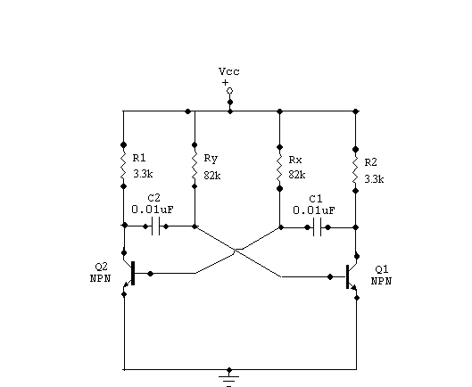

ASTABLE MULTIVIBRATOR WITH VERTICAL EDGES

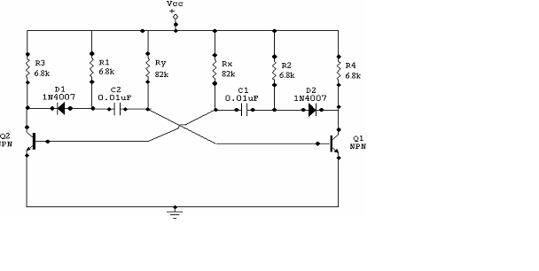

PROCEDURE
1Test all the components using multimeter.
2. Connect the components as in circuit diagram.
3. Observe the waveforms of both the transistors.

RESULT

Astable multivibrator with and without vertical edges were set up .The output waveforms were plotted and studied.

INFERENCE

The circuit of astable multivibrator is setup according to the given diagram and output waveform of symmetric and asymmetric multivibrator is drawn.The curve edges of the square wave were eliminated using a diode . the diode is placed such that it blocks the charging path of the capacitor C₁ through R₁ . So the output voltage changes to V_{cc} simultaneously .

